PREDICT THE BURNED AREA OF FOREST FIRES WITH NEURAL NETWORKS

**Ans :**

**R Code :**

## Neural Network

########## Fireforests Data Set #########

forestfires <- read.csv('D:\\Data Science\\Excelr\\Assignments\\Assignment\\Neural Networks\\forestfires_r1.csv')

# custom normalization function

normalize <- function(x) {

return((x - min(x)) / (max(x) - min(x)))

}

# apply normalization to entire data frame

forestfires_norm1 <- as.data.frame(lapply(forestfires[3:31], normalize))

# create training and test data

forestfires_train <- forestfires_norm1[1:361, ]

forestfires_test <- forestfires_norm1[362:517, ]

## Training a model on the data ----

# train the neuralnet model

library(neuralnet)

# simple ANN with only a single hidden neuron

forestfires_model <- neuralnet(size_category ~ FFMC + DMC + DC + ISI + temp + RH + wind + rain + area,

data = forestfires_train,

linear.output = FALSE,

err.fct = 'ce',

likelihood = TRUE)

# visualize the network topology

plot(forestfires_model)

## Evaluating model performance ----

# obtain model results

model_results <- compute(forestfires_model, forestfires_test)

# obtain predicted strength values

predicted_size <- model_results$net.result

# examine the correlation between predicted and actual values

cor(predicted_size, forestfires_test$size_category)

## Improving model performance ----

# a more complex neural network topology with 5 hidden neurons

forestfires_model2 <- neuralnet(size_category ~ FFMC + DMC + DC + ISI + temp + RH + wind + rain + area,

data = forestfires_train,

linear.output = FALSE,

err.fct = 'ce',

likelihood = TRUE, hidden =c(5,2))

# plot the network

plot(forestfires_model2)

# evaluate the results as we did before

model_results2 <- compute(forestfires_model2, forestfires_test)

predicted_size2 <- model_results2$net.result

cor(predicted_size2, forestfires_test$size_category)

**Results :**

> cor(predicted_size, forestfires_test$size_category)

[,1]

[1,] 0.9384515

> cor(predicted_size2, forestfires_test$size_category)

[,1]

[1,] 0.9433175

**Plots :**

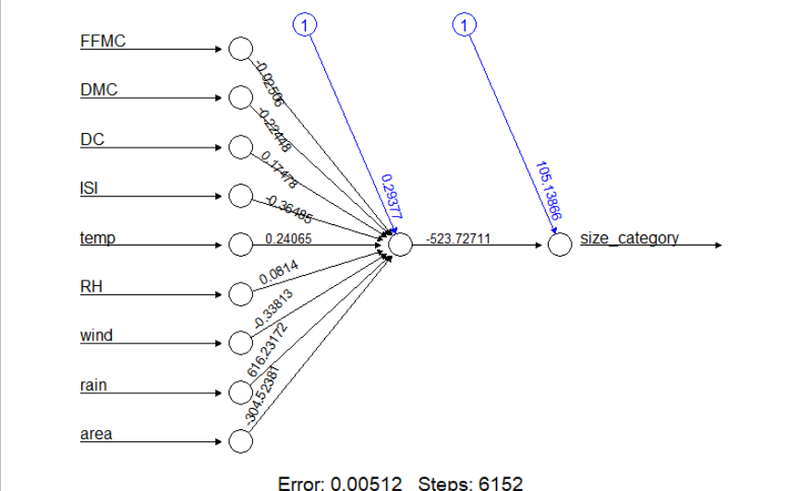

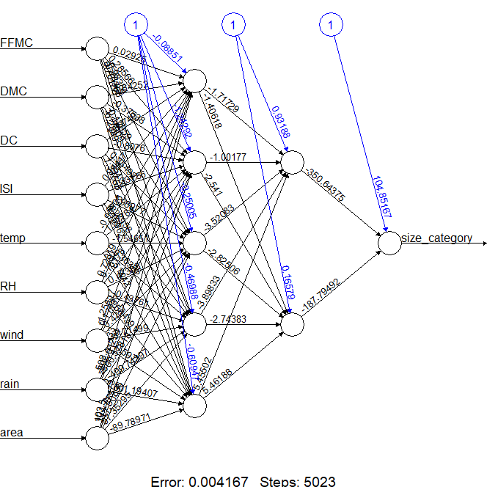

**Inference :**

Getting more accuracy with the extra hidden layers.